1. Select the Add on option on Mozilla Firefox via open Menu option at the right hand side top

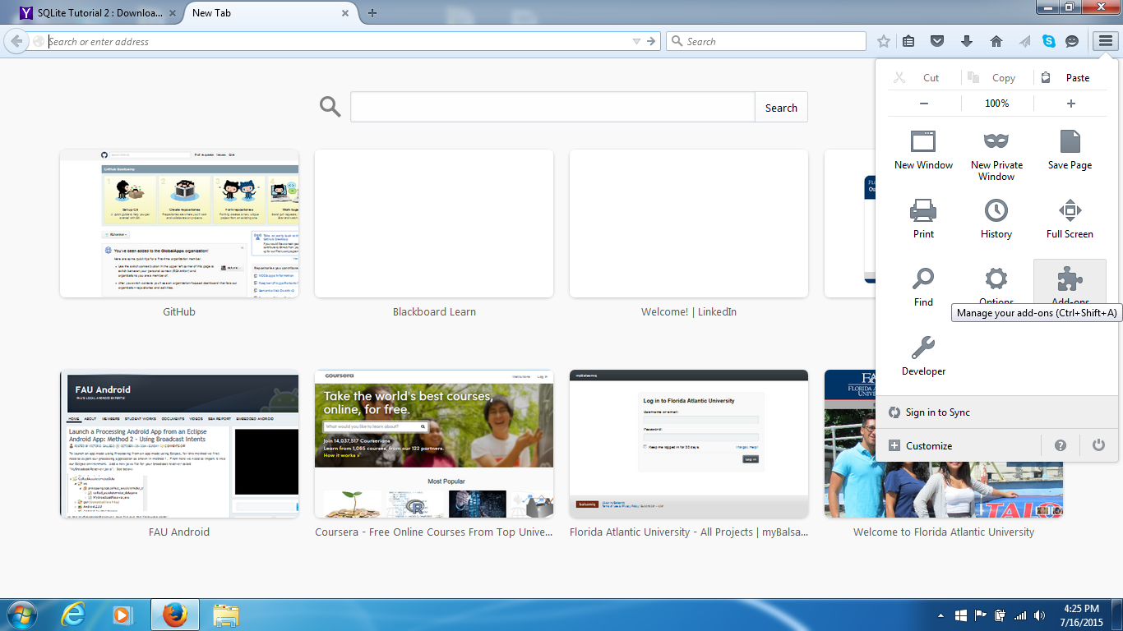

1. Type in sqlite in the search window at right hand side top

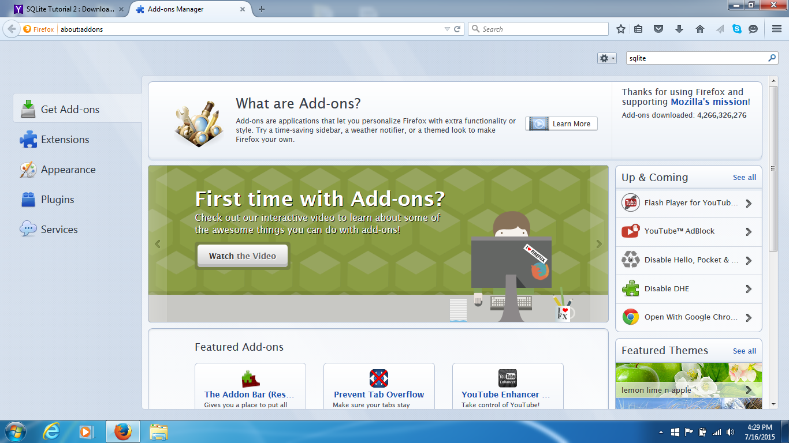

1. Install SQLite manager (the highlighted version)

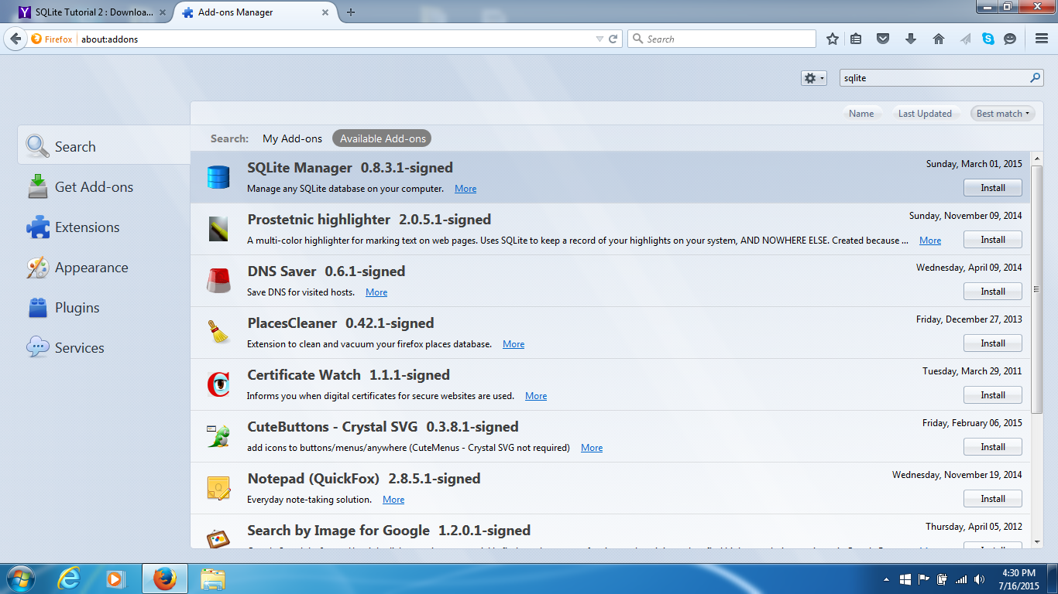

1. After restart of Mozilla Firefox, you will find it under MyAdd-ons

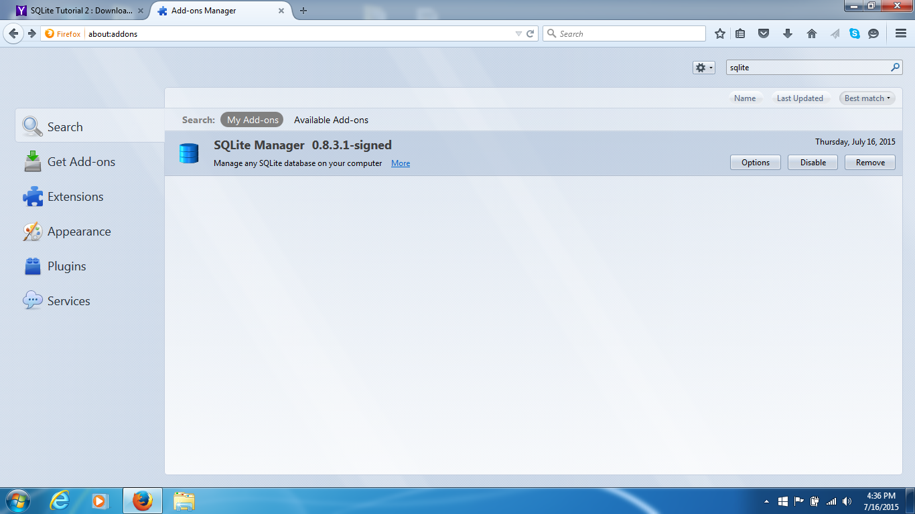

1. Click on options and note the options-for example double quotes

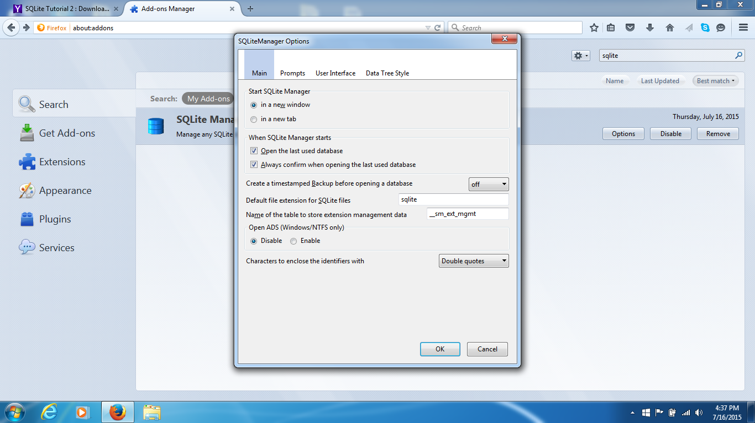

1. Choose Customize Option

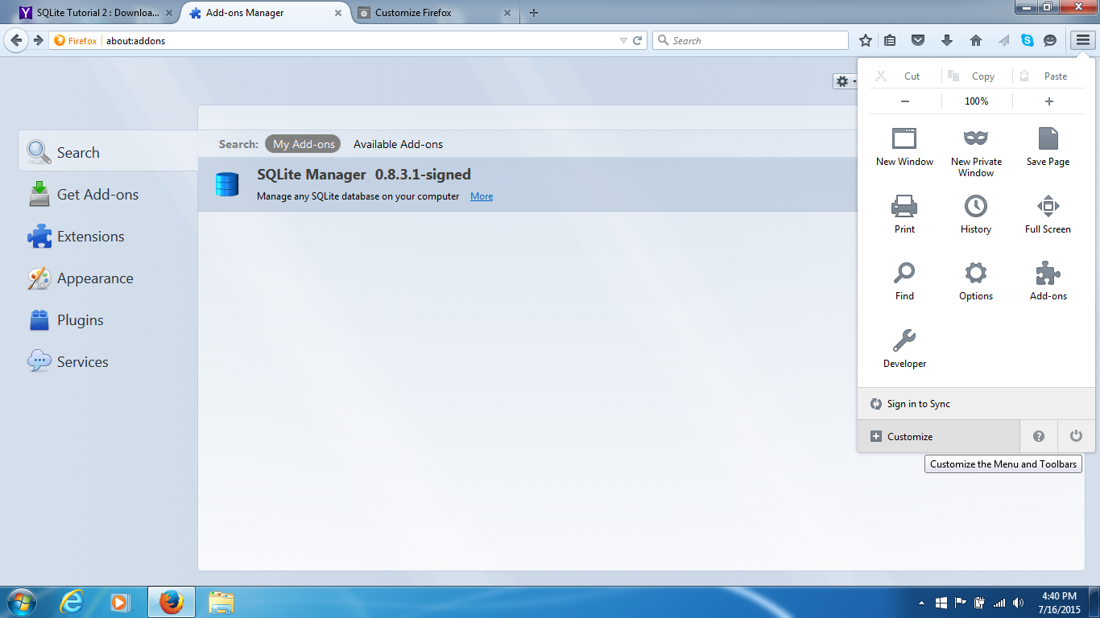

1. Note SQLite Manager under ‘Additional Tools and Features’

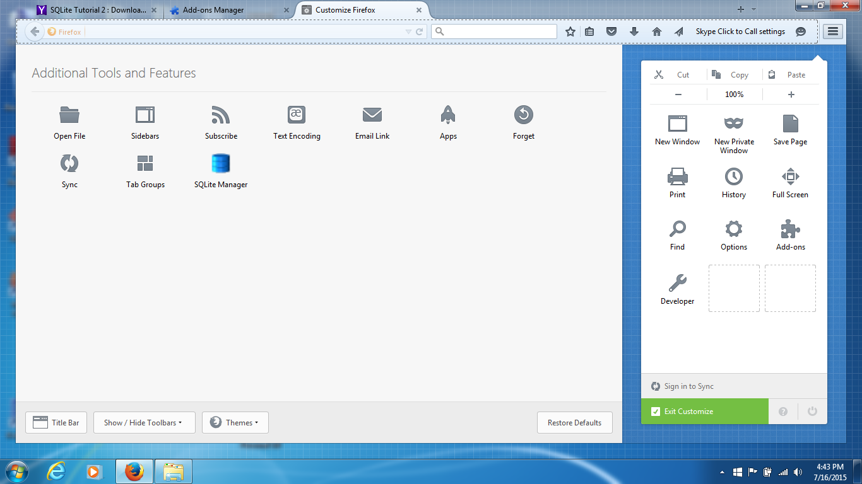

1. Move it to the Settings icon List as shown and Exit Customize

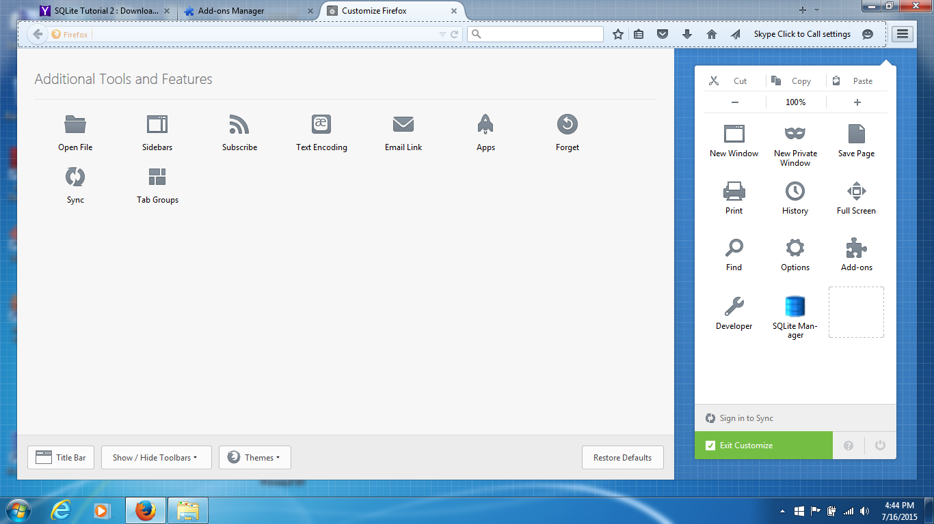

1. Open Android Studio and copy the mobile_trivia db file

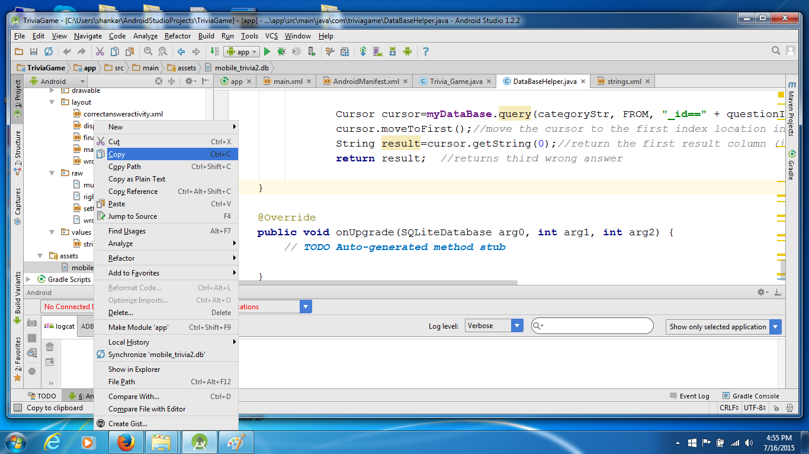

1. Save in your folder- note it will not have.txt logo- it will look like a non-descript file

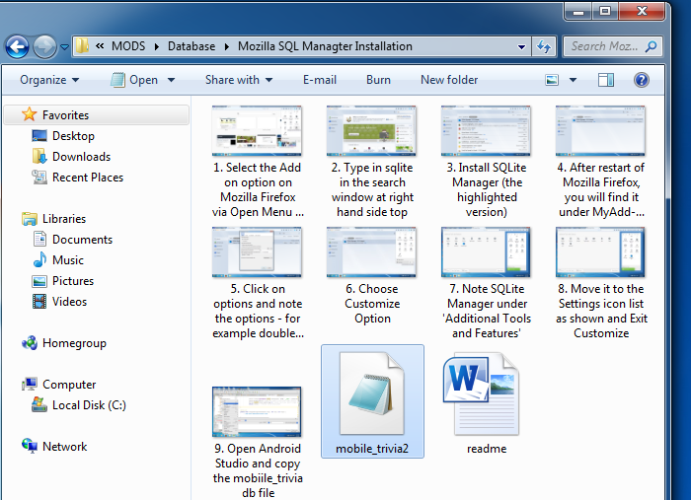

1. Double click on SQLite Manager icon and open this window

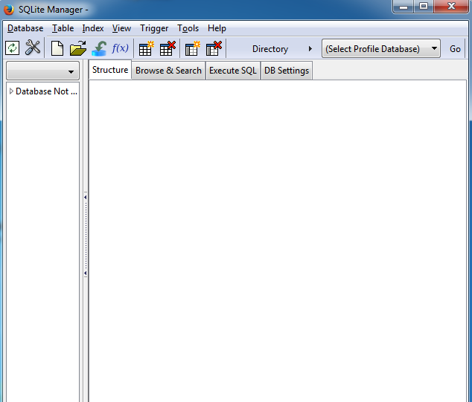

1. Choose Connect Database option –then navigate to where you have stored the db file

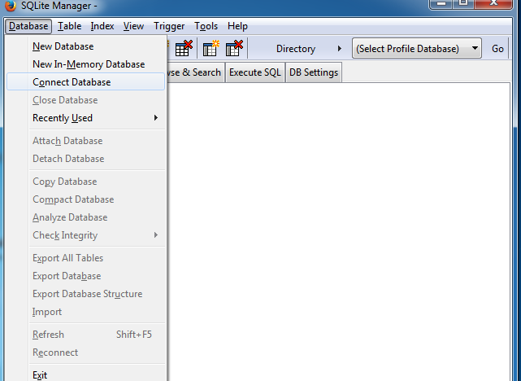

1. Choose the .db file- it will now open in SQLite Manager

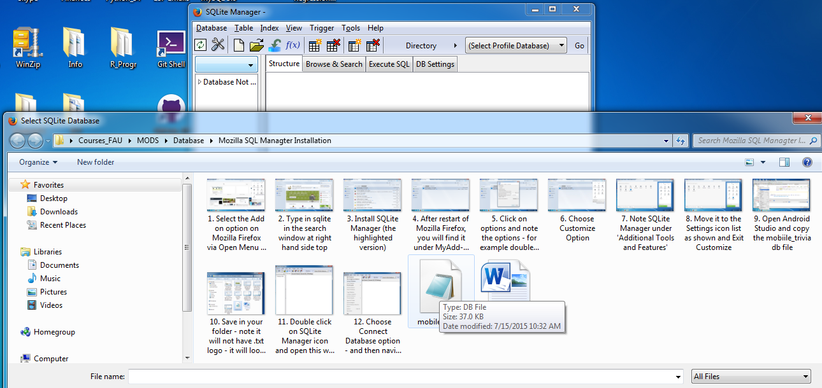

1. I expanded the window a bit so you can see the tables on the left hand side

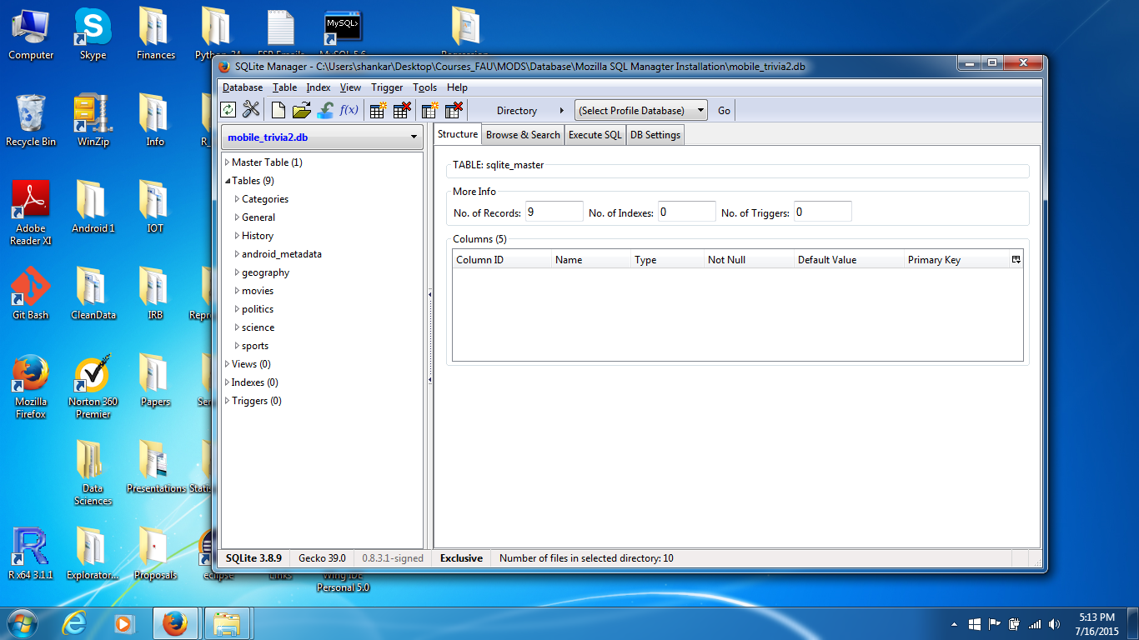

1. For History note the structure- I have clicked on the Structure tag on the right hand side window

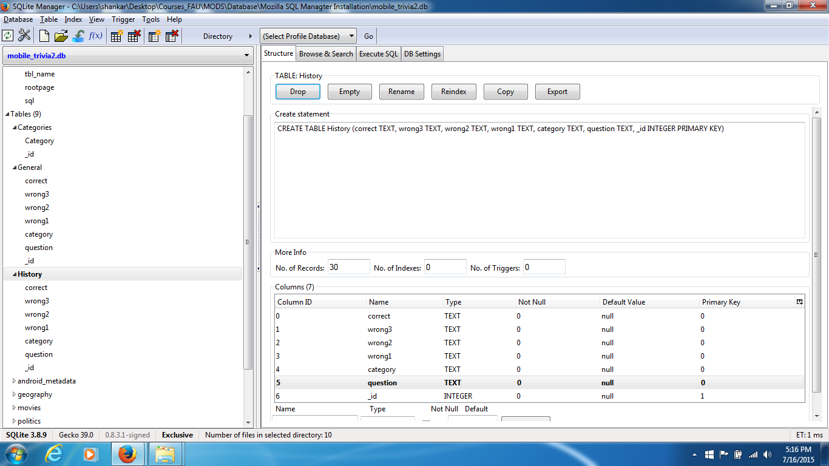

1. For history note the actual records entered- I have clicked on the Browse & Search window

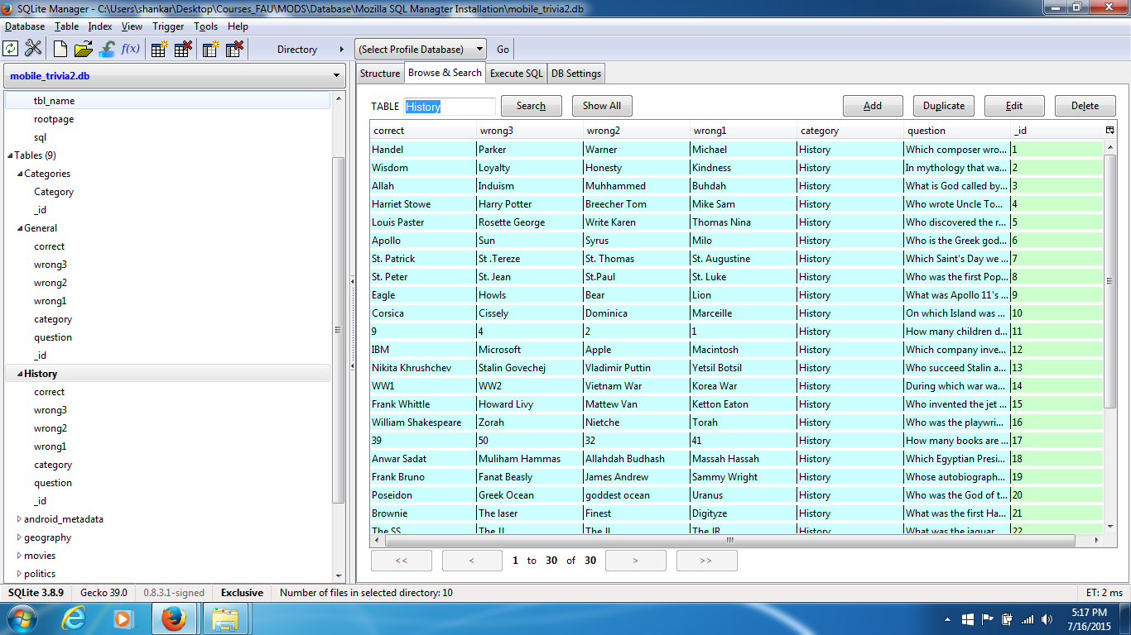

1. Make modifications (edit, add, remove, delete, rename, etc) -I just changed ‘Induism’ to ‘Hinduism’ and hit OK

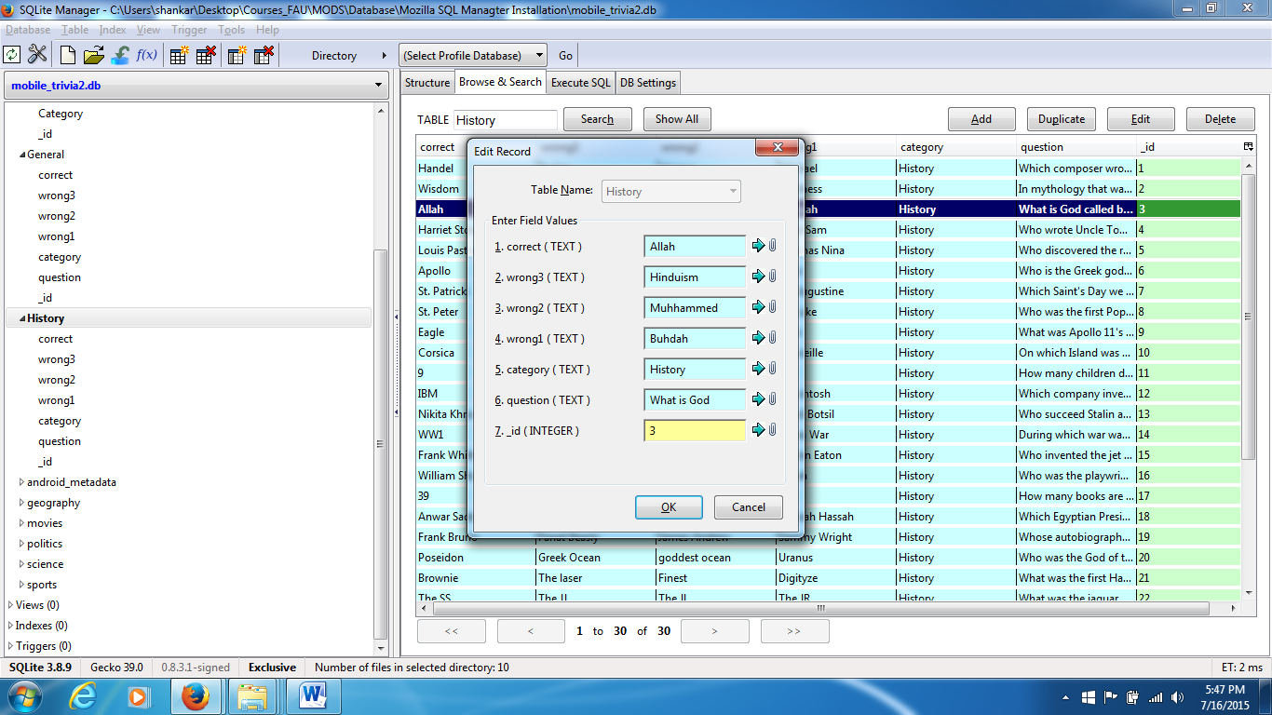

1. Click OK here –it is showing SQLite command here-note that SQL uses create, read, update, delete (CRUD) in its command structure

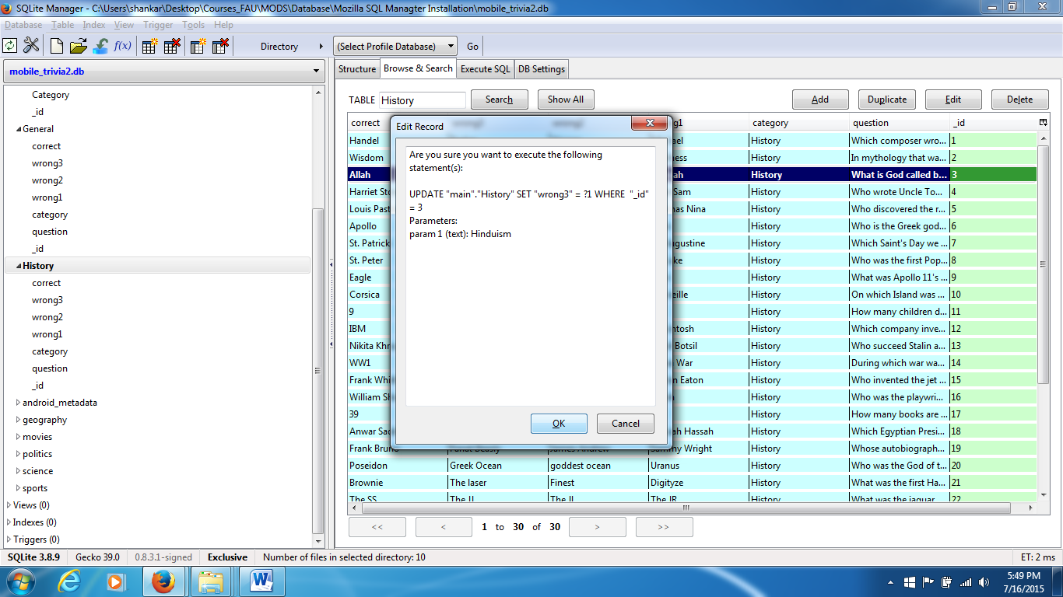

1. Choose close database after you have made changes –it saves automatically

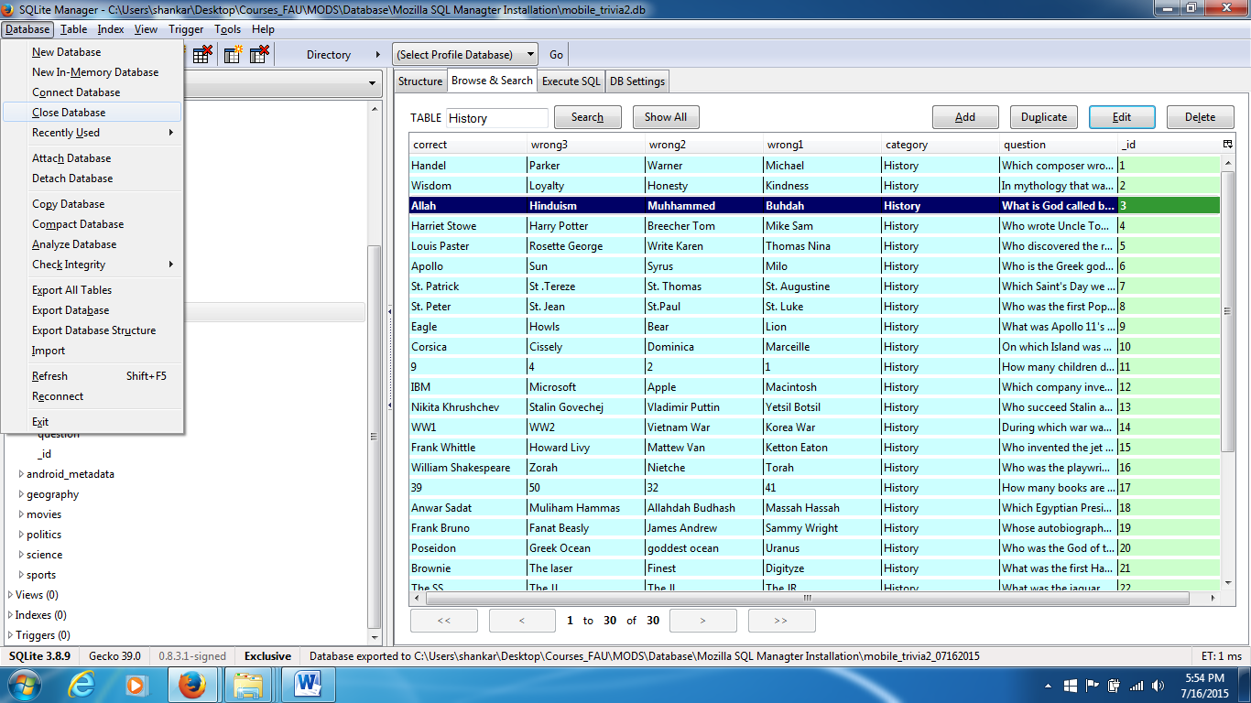

1. Connect to the database again and note that the update has occurred. Close the database and exit SQLite Manager-follow these steps properly

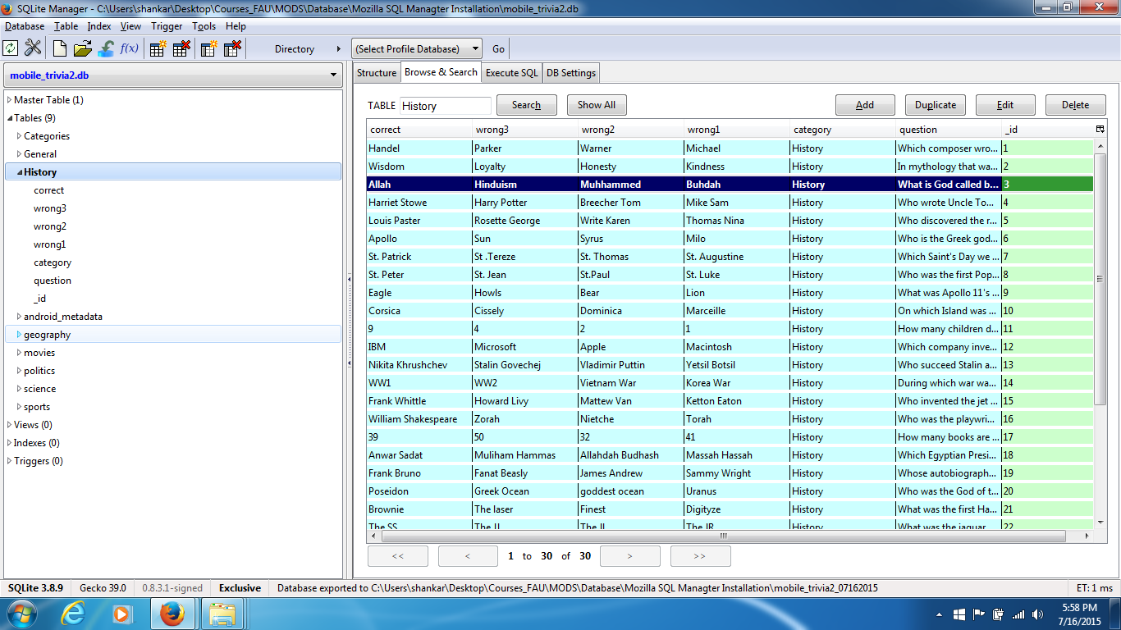

“I followed the directions here:

<https://video.search.yahoo.com/video/play;_ylt=A2KLqIJVEqhVaVAA6RUsnIlQ;_ylu=X3oDMTByNDV2czA1BHNlYwNzcgRzbGsDdmlkBHZ0aWQDBGdwb3MDOQ--?p=Getting+Started+With+Sqlite+Manager&vid=20fea80e7a0a31abed9e22d3aa61172a&turl=http%3A%2F%2Fts2.mm.bing.net%2Fth%3Fid%3DWN.aNMi4Z2dAd9DcVAI71ZKJg%26pid%3D15.1%26h%3D173%26w%3D300%26c%3D7%26rs%3D1&rurl=https%3A%2F%2Fwww.youtube.com%2Fwatch%3Fv%3DqKZb-K4oQ8k&tit=SQLite+Tutorial+2+%3A+Download+and+Install+Free+SqLite+GUI+Manager+for+Windows&c=8&h=173&w=300&l=1326&sigr=11b3sbod6&sigt=12ch2d8in&sigi=12khol8vp&age=1369685330&fr2=p%3As%2Cv%3Av&fr=yhs-mozilla-003&hsimp=yhs-003&hspart=mozilla&tt=b>

The above is for SQLite manager. Its usage is described with screenshots attached with this readme file. Once you open it, you should be able to edit it to your set of questions with edit/remove/add etc buttons provided.

However, if you want to use the command tool or understand more on the relational databases, here is the author’s earlier video:

<https://video.search.yahoo.com/video/play;_ylt=A2KLqIJVEqhVaVAA4RUsnIlQ;_ylu=X3oDMTByZWc0dGJtBHNlYwNzcgRzbGsDdmlkBHZ0aWQDBGdwb3MDMQ--?p=Getting+Started+With+Sqlite+Manager&vid=3886dd7280ab37a1042c2ea12f8cbcd7&turl=http%3A%2F%2Fts1.mm.bing.net%2Fth%3Fid%3DWN.vUPc%252biVS9Z3Z1uELyymnuA%26pid%3D15.1%26h%3D187%26w%3D300%26c%3D7%26rs%3D1&rurl=https%3A%2F%2Fwww.youtube.com%2Fwatch%3Fv%3DU7nfe4adDw8&tit=SQLite+Tutorial+1+%3A+Getting+started+with+SQLite+and+Installation&c=0&h=187&w=300&l=548&sigr=11bbf1p1h&sigt=120kighb4&sigi=12mbjoo03&age=1369602905&fr2=p%3As%2Cv%3Av&fr=yhs-mozilla-003&hsimp=yhs-003&hspart=mozilla&tt=b>

Note that relational databases use the principle of CRUD (Create/read/update/delete) in reading. Also, there is the process of connecting and closing the connection to ensure that the database is accessed in a structured and restricted manner (so the data is not corrupted etc). This first/earlier video might help you see the bigger picture, but may not be needed. “